|  |
| --- |
| By Cliff Rodriguez |
| Problem Set 6 |
| Date |

|  |
| --- |
| Cliff Rodriguez  [Date] |

Contents

# Question 1

1. One advantage of using the data on the dummy resumes is that the values for the entire dataset can be obtained. Next, assuming the full set of values were able to be obtained, the selection process for aggregating the data for real life resumes would be questions and there is no ideal way to select the data, which would lead to selection bias.



T > .05, we can conclude the callback rate for African-American and Caucasian is not the same.

1. I would not expect the result to change, meaning that I would expect in every state and city in America a Caucasian sounding and African-American sounding name will have different callback rates for resumes submitted to job postings. Regarding the value of the co-efficient, I would expect that to change because at least one covariate has been added, which impacts the coefficient predicted. Still need model
2. Still needed
3. Still needed
4. Still needed

# Question 2



T > 1.96, therefore we can conclude with confidence that a minority borrower is denied a load more frequently than a non-minority borrower.

1. According to the results, we expect that 97 out of 1000 borrowers that is non-minority is denied a loan.
2. Based on the results 26 percent of minority borrowers are denied. This difference is significant at the 5% level. (double check)
3. Based on the data available, we are unable to demonstrate that there was not discrimination; when all variables are included being a minority is a significant predictor of being denied a loan.
4. Still needed
5. 
6. The payment tin to income ratio explains 57% of the rate of denial for borrowing applicants.
7. Because p < 0.05 for minority, and t > 1.96 it can be concluded that minority is a significant predictor for increased denial in approval for borrowing. This claim does not support the loan officer, being a minority still significantly impacts getting a loan. This is proven with the t stat and p-value comparison above.
8. Still needed
9. 
10. The estimate on the minority coefficient is .09, this is a decrease from the value of .16 which was obtained in part (a). Having statistical significance at the 5 percent level for both regressions indicates that lending practices in Boston in the 1990’s was discriminatory and placed minorities at a disadvantage (no big surprise).

# Question 3





185 men participated in the program.

24 was the maximum number of months a person was enrolled in the program.



F- value = 1.6, which is less than 1.96; the variables are not jointly significant. (confirm)

|  |  |  |
| --- | --- | --- |
| Coefficient (LPM) | Variable name | Significance |
| $${\hat{β}}_{1}= .021$$ | unem74 | p-value > .05; not significant |
| ${\hat{β}}_{2}= -.096$ | unem75 | p-value > .05; not significant |
| ${\hat{β}}_{3}= .003$ | age | p-value > .05; not significant |
|  | educ | p-value > .05; not significant |
| ${\hat{β}}_{5}= -. 081$ | black | p-value > .05; not significant |
| ${\hat{β}}_{6}= -.200$ | hisp | p-value > .05; not significant |
| $${\hat{β}}_{7}= .037$$ | married | p-value > .05; not significant |

1. Probit Model

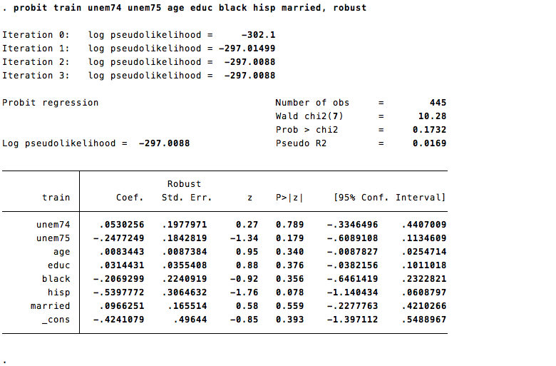



| Coefficient (LPM) | Coefficient Probit | Variable name | Significance |
| --- | --- | --- | --- |
| $${\hat{β}}_{1}= .021$$ | $${\hat{β}}_{1}= .021$$ | unem74 | p-value > .05; not significant |
| ${\hat{β}}_{2}= -.096$ | ${\hat{β}}_{2}= -.096$ | unem75 | p-value > .05; not significant |
| ${\hat{β}}_{3}= .003$ | ${\hat{β}}_{3}= .003$ | age | p-value > .05; not significant |
|  |  | educ | p-value > .05; not significant |
| ${\hat{β}}_{5}= -. 081$ | ${\hat{β}}_{5}= -. 081$ | black | p-value > .05; not significant |
| ${\hat{β}}_{6}= -.200$ | ${\hat{β}}_{6}= -.210$ | hisp | p-value > .05; not significant |
| $${\hat{β}}_{7}= .037$$ | $${\hat{β}}_{7}= .037$$ | married | p-value > .05; not significant |

Based on the probit model, the coefficient predictions do vary slightly from model to model, but are the same to the third significant digit.

1. = .37(0)+20*(.003)+.021(1)+ [(-.096)*(1)]+.12*(11)

=0+.06+.21-.096+

1. Still needed
2. Still needed
3. Still needed



Based on the regression above the estimated result for being in a job training program decreases the probability of being unemployed in 1978 for males by 11 percent.

p-value (train) < .05; **significant**

1. The coefficients of produced by the Probit model regression are not able to interpretable, or able to be used to compare. To get the values needed to compare marginal effects the margins command is used.



